**Command line integration with Newman**

Newman is a command line Collection Runner for Postman. It allows us to run and test a Postman Collection directly from the command line. It is built with extensibility in mind so that we can easily integrate it with our continuous integration servers and build systems.

**Installation & Command line Running**

* Newman is built on Node.js. To run Newman, make sure you have Node.js installed. (Node.js >= v6)
* Run following command on the command line “**npm install -g newman**”
* The easiest way to run Newman is to run it with a collection, create a collection in postman and exported collection as json file.
* Create collection using postman

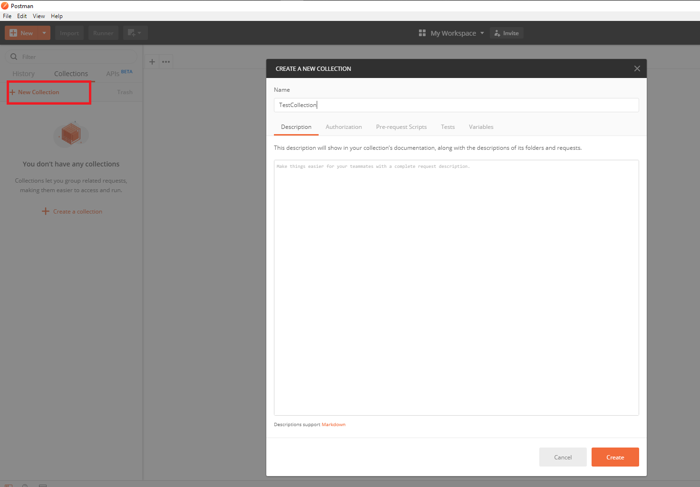

* Add Get/Post requests using “Add Request” over here.

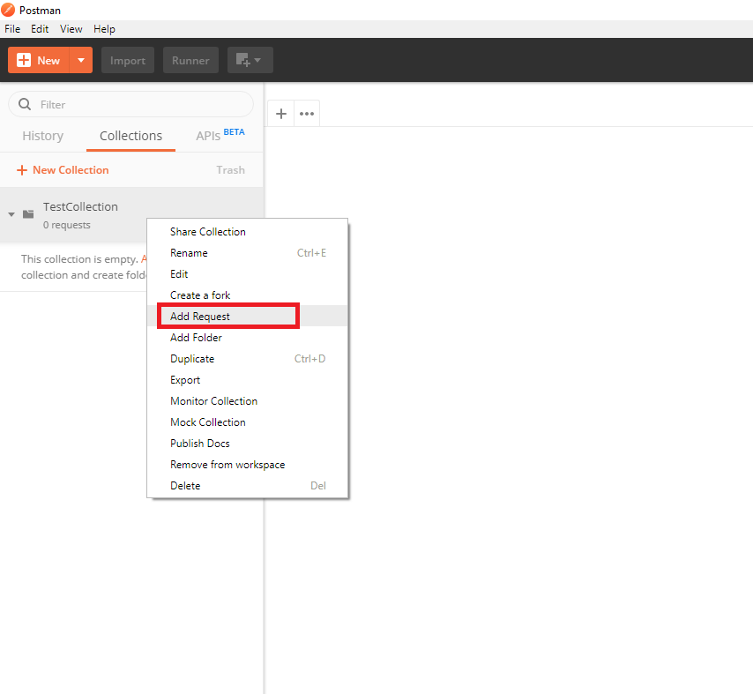

* Add assertion using Tests tab under a particular Request

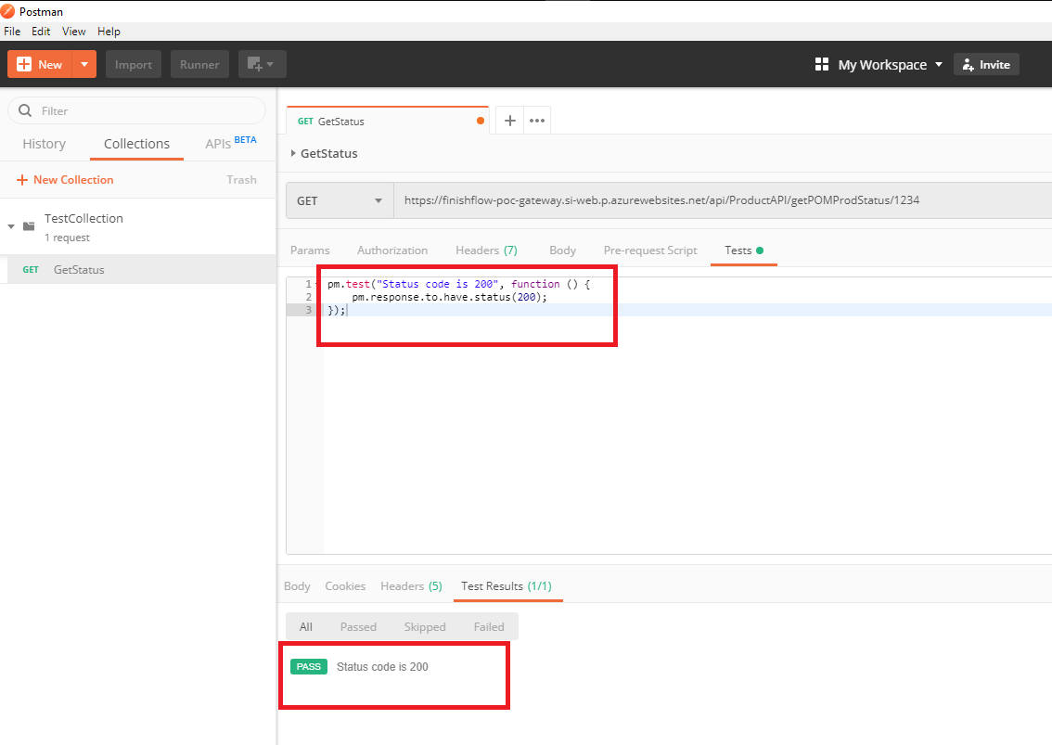

* For the POC purpose we have created 4 Different collections for sequential flow of execution.

1. NavigationTest
2. ValueSummaryCapability
3. ProductCapability
4. PaperCheckListCapability

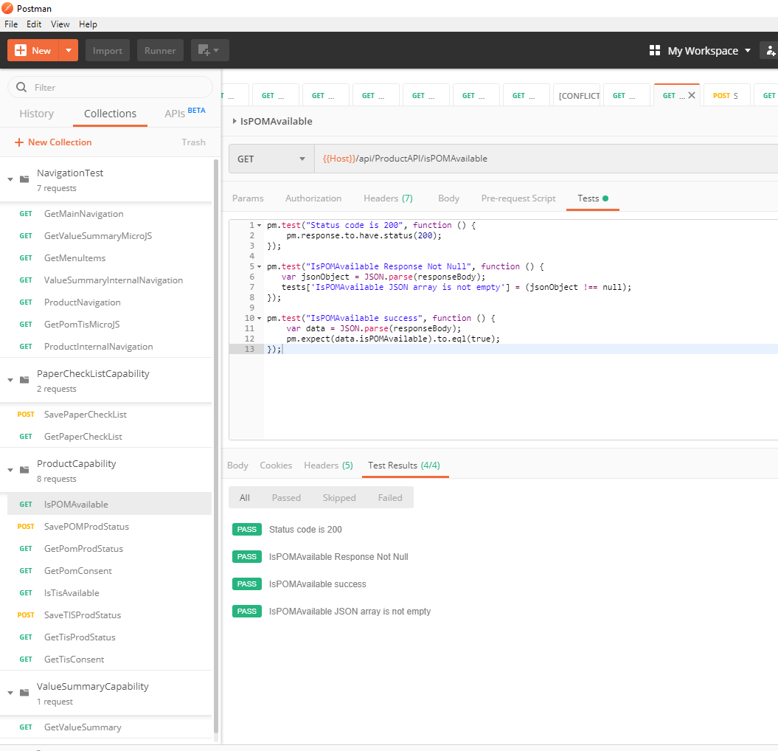

* Collection probably uses environment variables, to create environment variables use

Manage environment option from the postman.

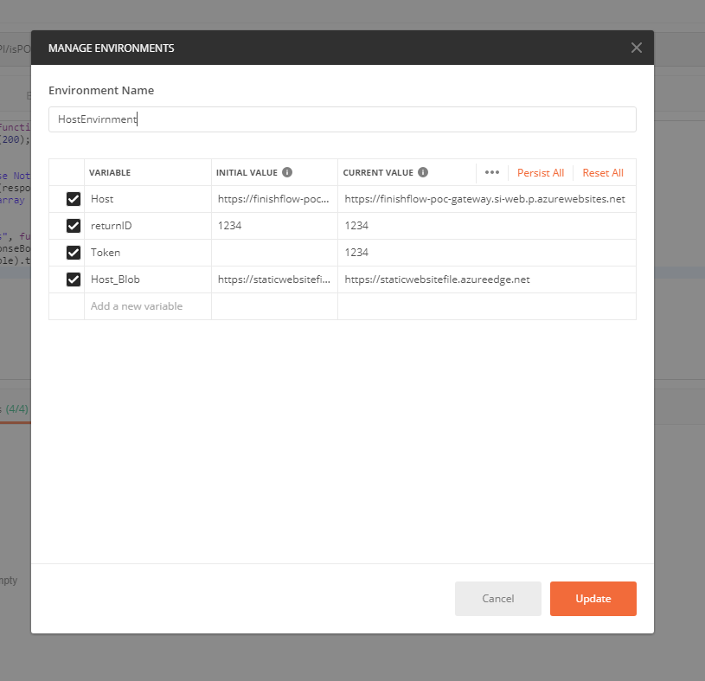

* Use environment variable in the collection requests.

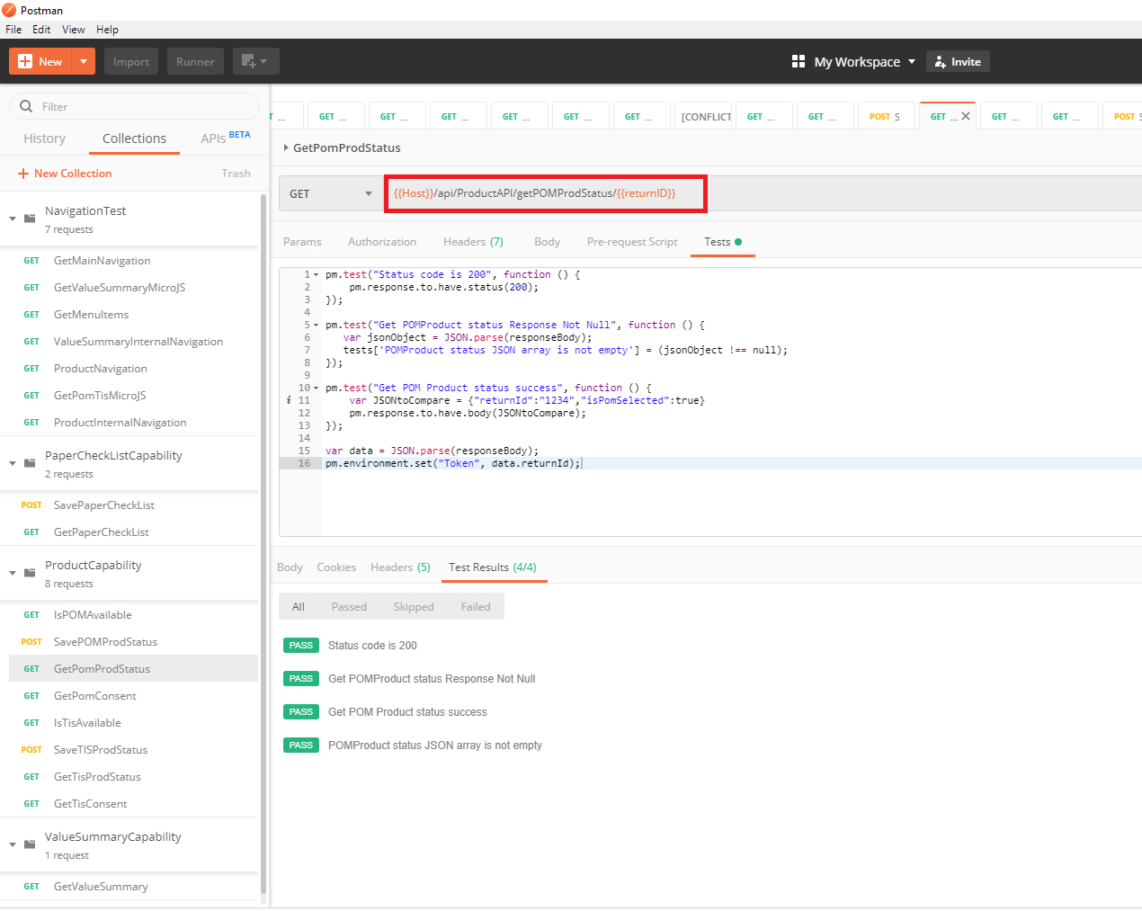

**Create the environment from Manage Environment and exported it as a json file and use it while running the collection.**

* Also, we can dynamically set an environment variable using Test Script

**var data = JSON.parse(responseBody);**

**pm.environment.set("Token", data.returnId);**

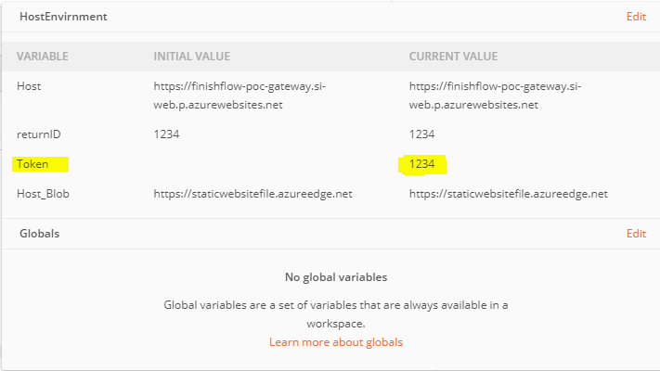

* Run following command on the command line” **newman run** **Testcollection.json** **-e dev_environment.json**”. It will run the postman collection along with Environment file in the newman command line and shows the result.

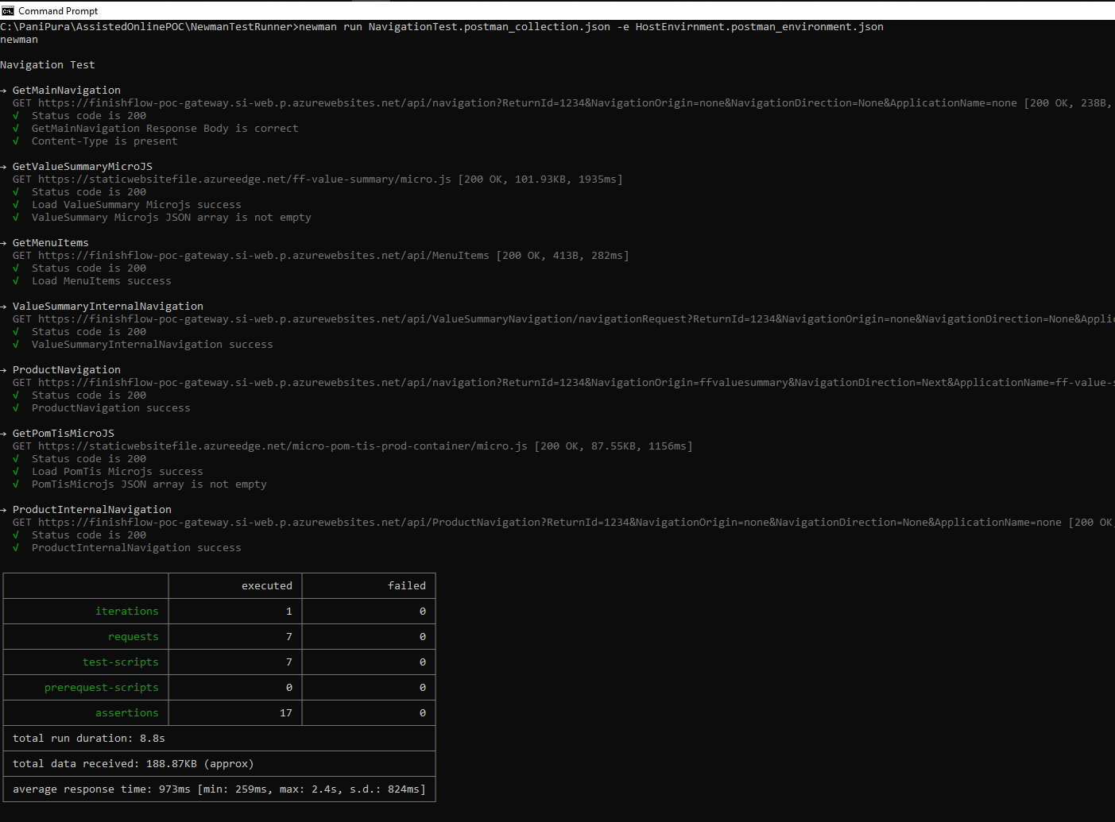

**Configuring Postman API Tests to Newman tool in Azure DevOps**

* Create a New build pipeline / we can reuse the existing one for integration.
* Adding build tasks to Azure DevOps build pipeline.

1. **Install newman**: Task having command script to install newman in the build agent.

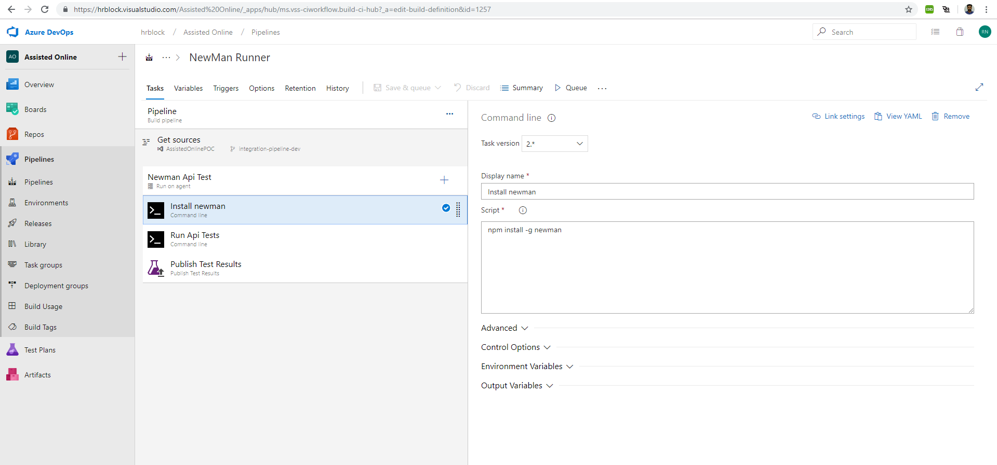

1. **Run Api Tests**: Task having script to Run the postman collection json along with environment json and will create a Junit junitReport.xml in the working directory.

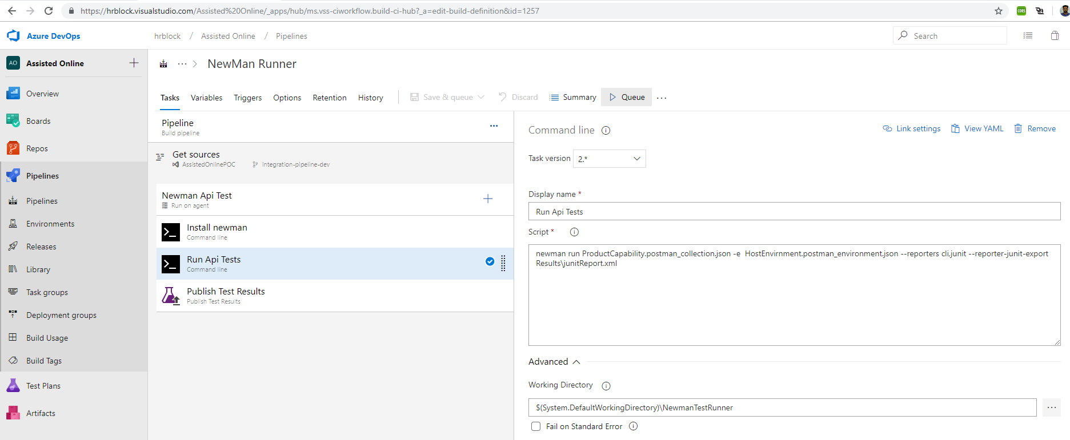

1. **Publish Test Results**: Task will find out the junitReport.xml file and publish out the test results.

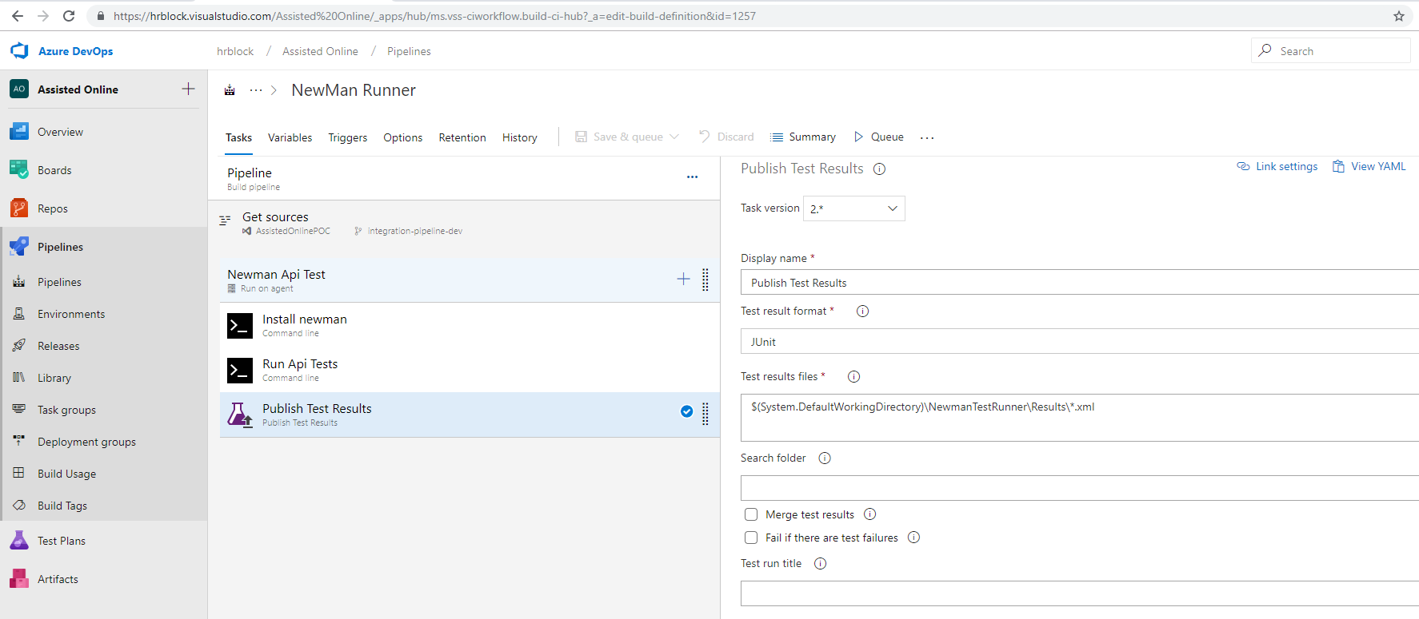

**Verifying the results after Save&Queue execution**

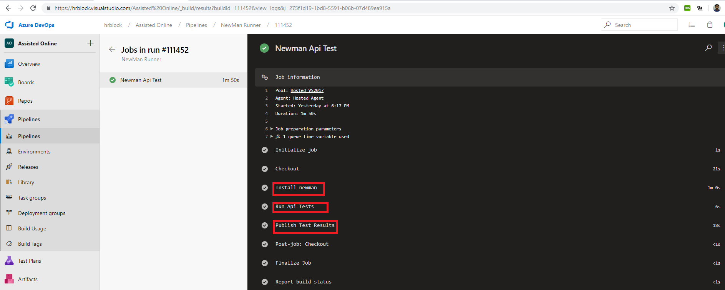

**Viewing the Test Summary**

Click on the **Tests**Tab to view the Test Summary

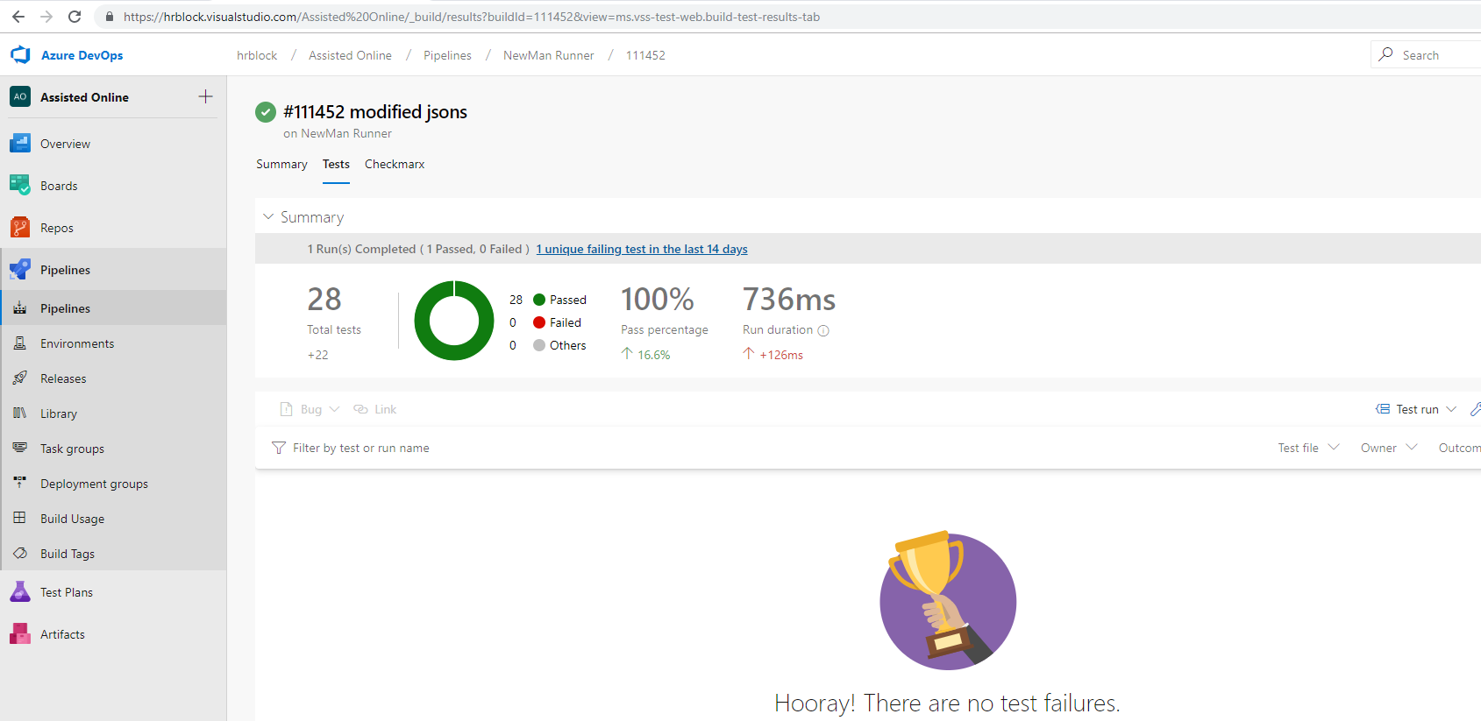

**View Test Execution Details**

* Click on the Publish Test Results Task

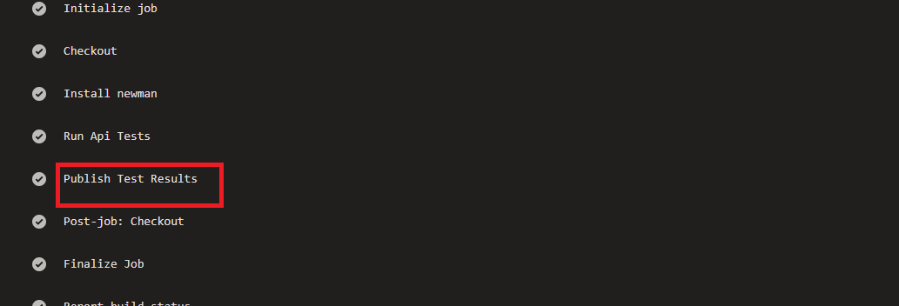

* Now Publish Test Results Window appears.
* Click on **Published Test Run** link as shown in image

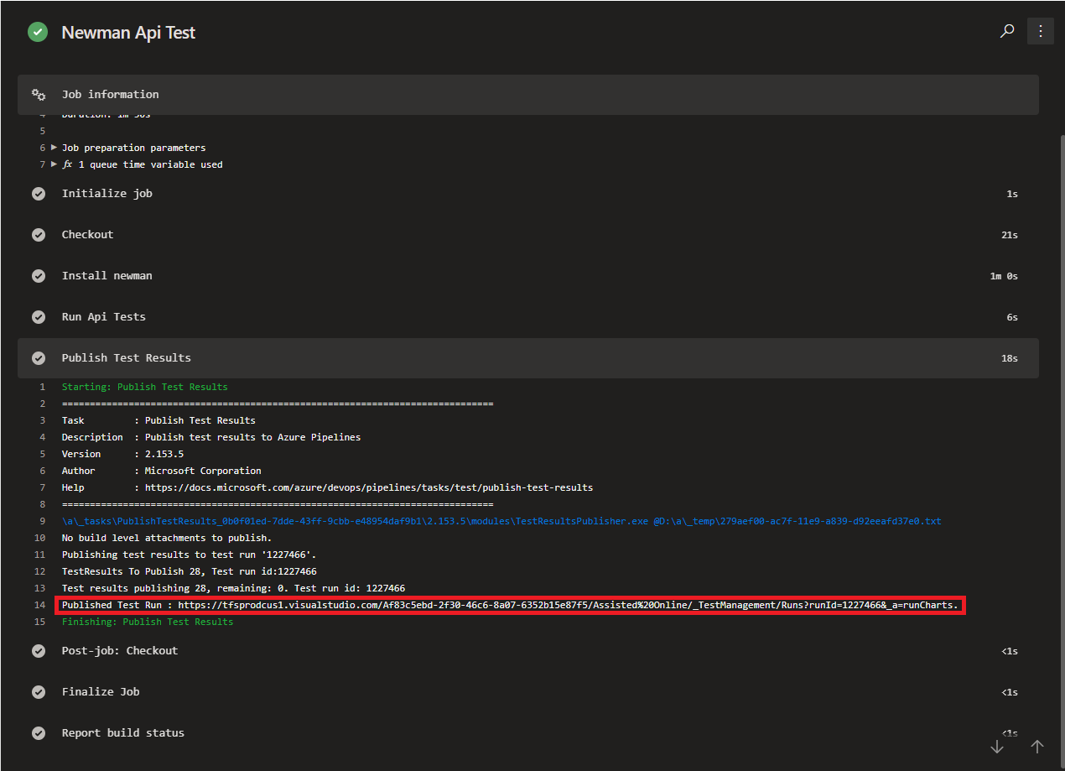

* The link will take you to the**Result Details** page

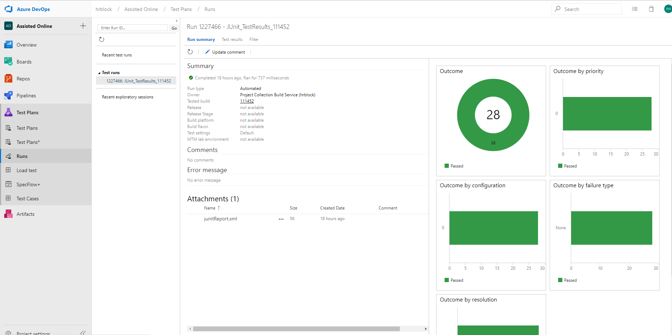

* Click on the **Test Results** Tab to view each test result

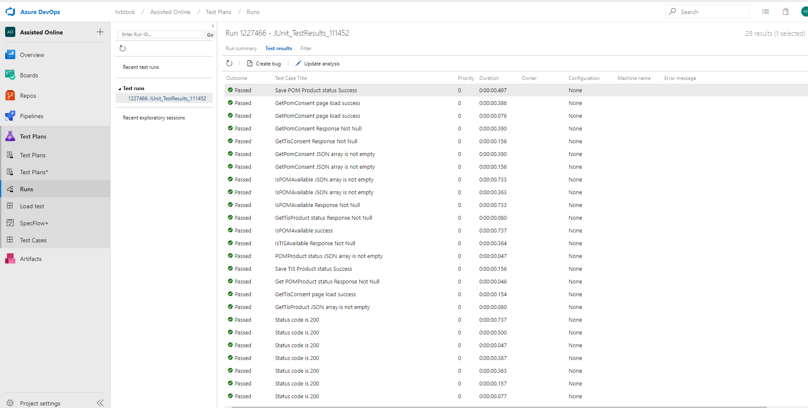

**Reference List:**

<https://learning.getpostman.com/docs/postman/collection_runs/command_line_integration_with_newman/>

<https://medium.com/@ganeshsirsi/how-to-configure-postman-newman-api-tests-in-azure-devops-or-tfs-and-publish-html-results-caf60a25c8b9>